917719C063

nitish@student.tce.edu

Pharma Sales Dashboard

Task 1: Sales By Customer

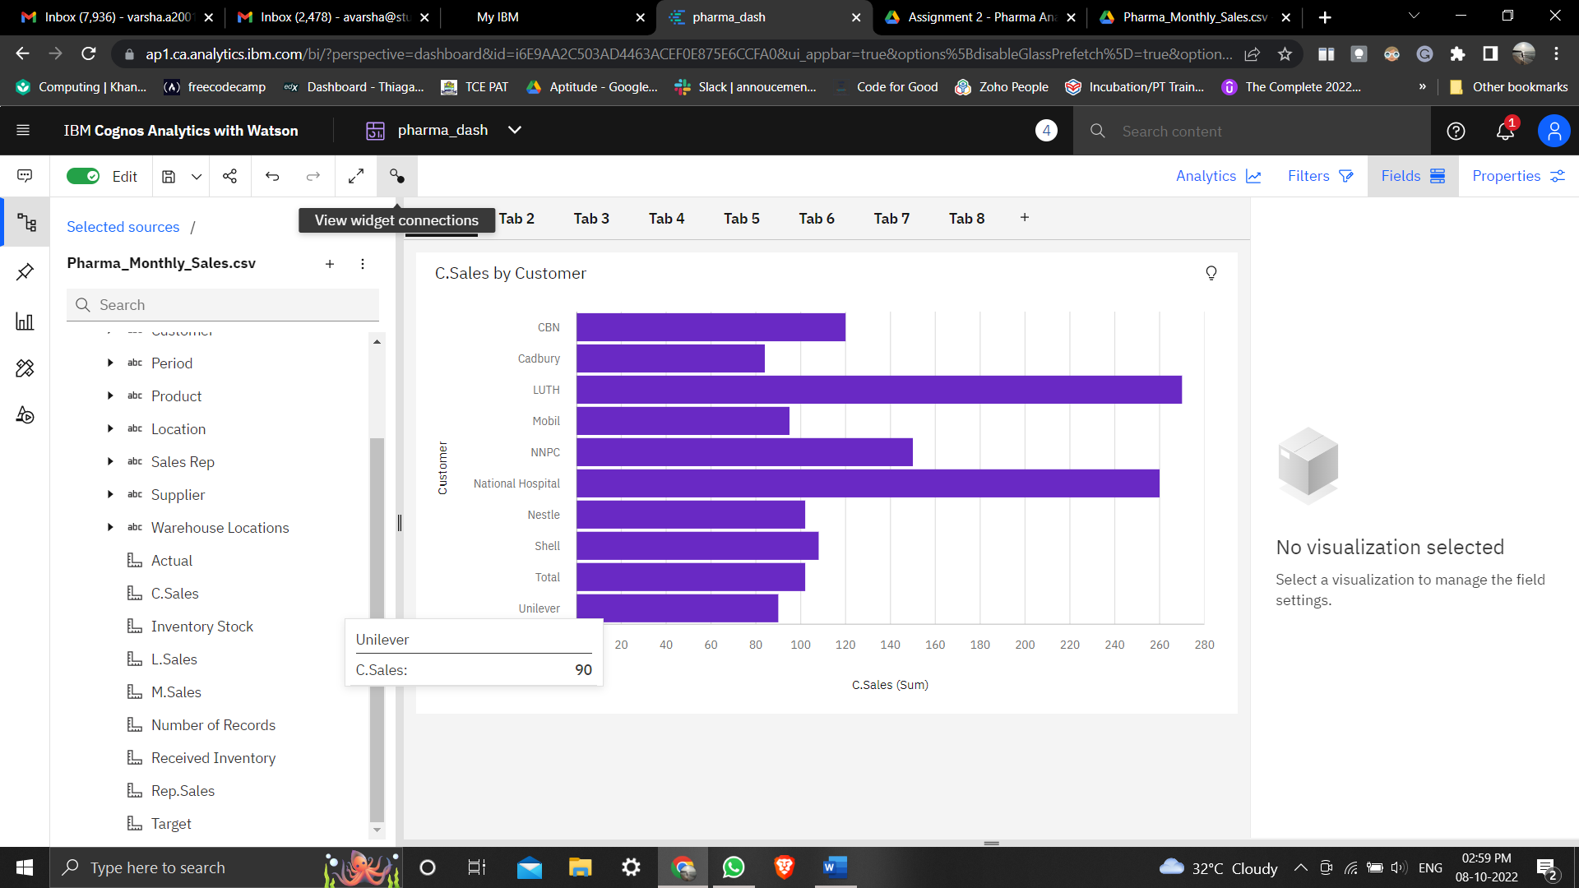

Task 2: Sales By Location

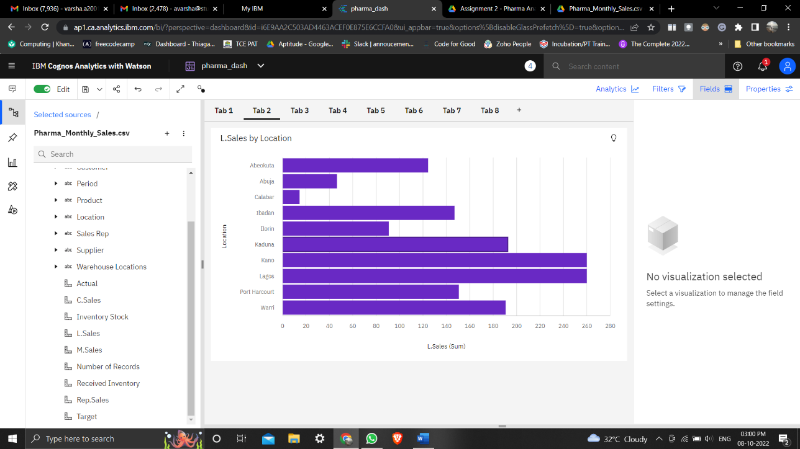

Task 3:Sales By Sales Representative.

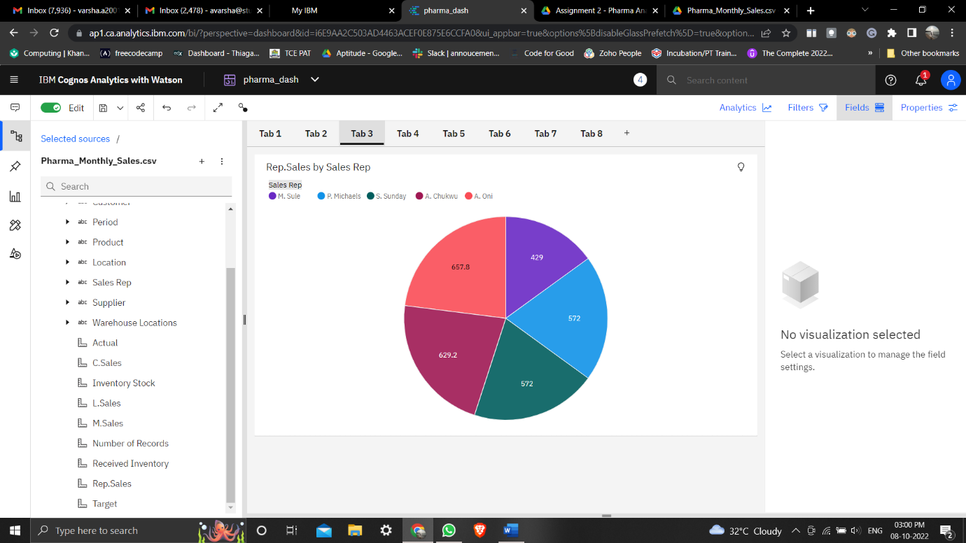

Task 4: Received Inventory From Supplier

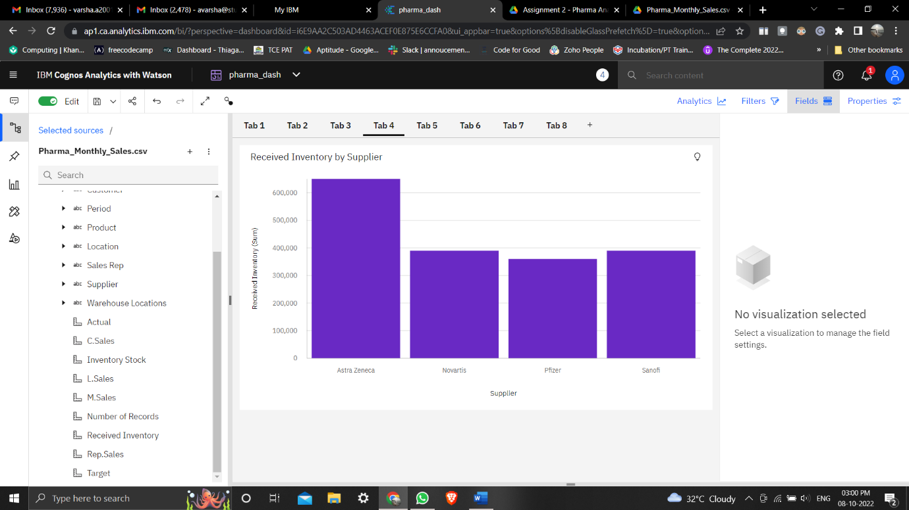

Task 5: inventory Stock for Warehouse Location

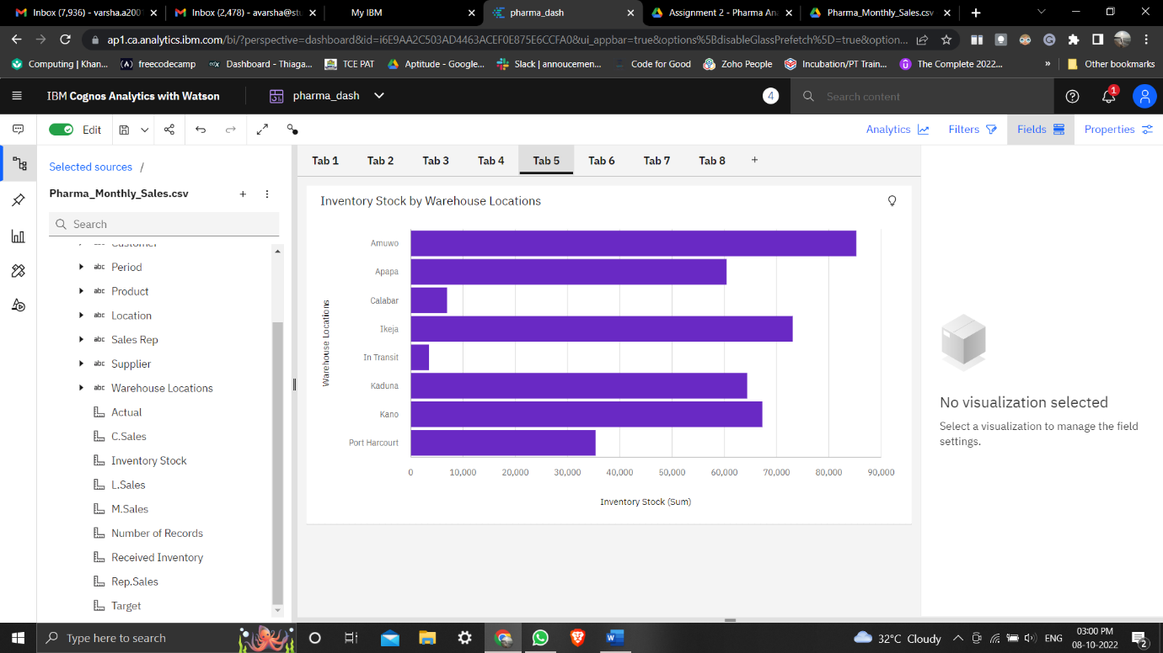

Task 6: Sales Trend

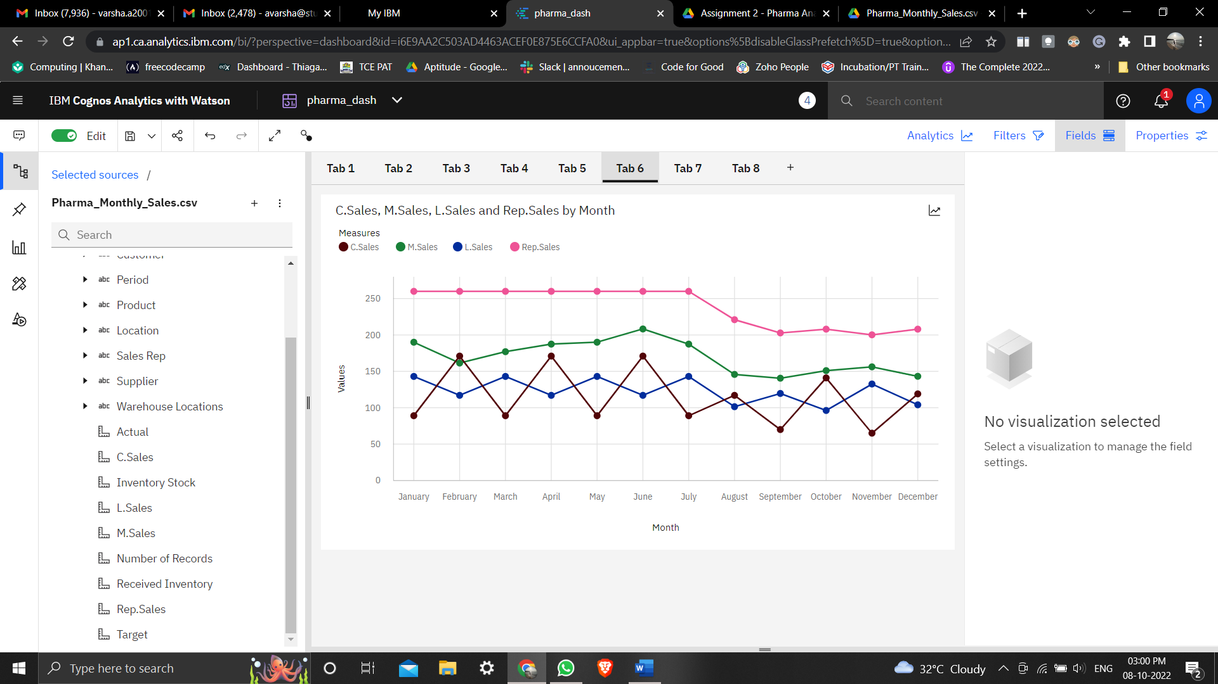

Task 7: Monthly Sales

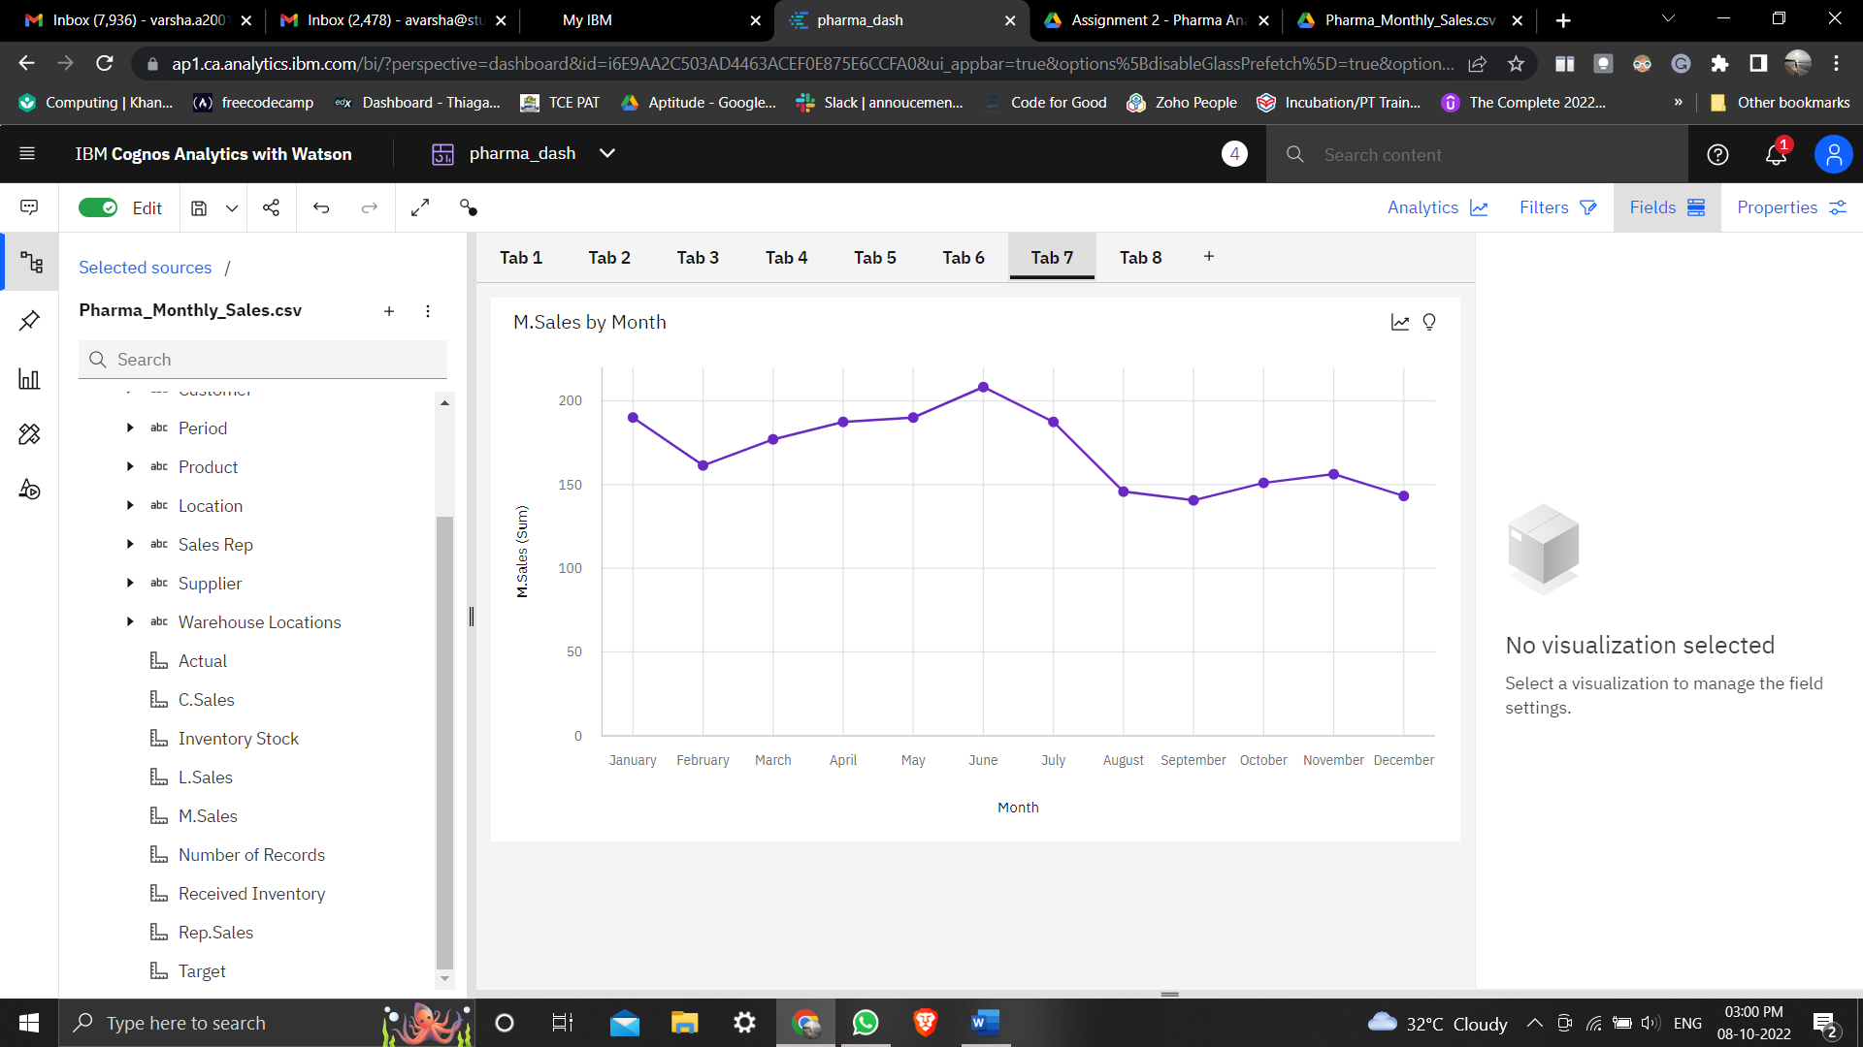

Task 8: Actual and Received Inventory By Month

